**USER MANUAL**

Table of Contents

1.0 General Information

1.1 System Overview

1.2 Organization of the Manual

2.0 System Summary

2.1 System Configuration

2.2 User Access Levels

3.0 Getting Started

3.1 Installation and Logging In

3.2 System Menu & Usage

3.3 Changing User ID and Password

3.4 Exit System

4.0 Using the System’s Functions

4.1 Using the System

4.2 Special Instructions for Error Correction

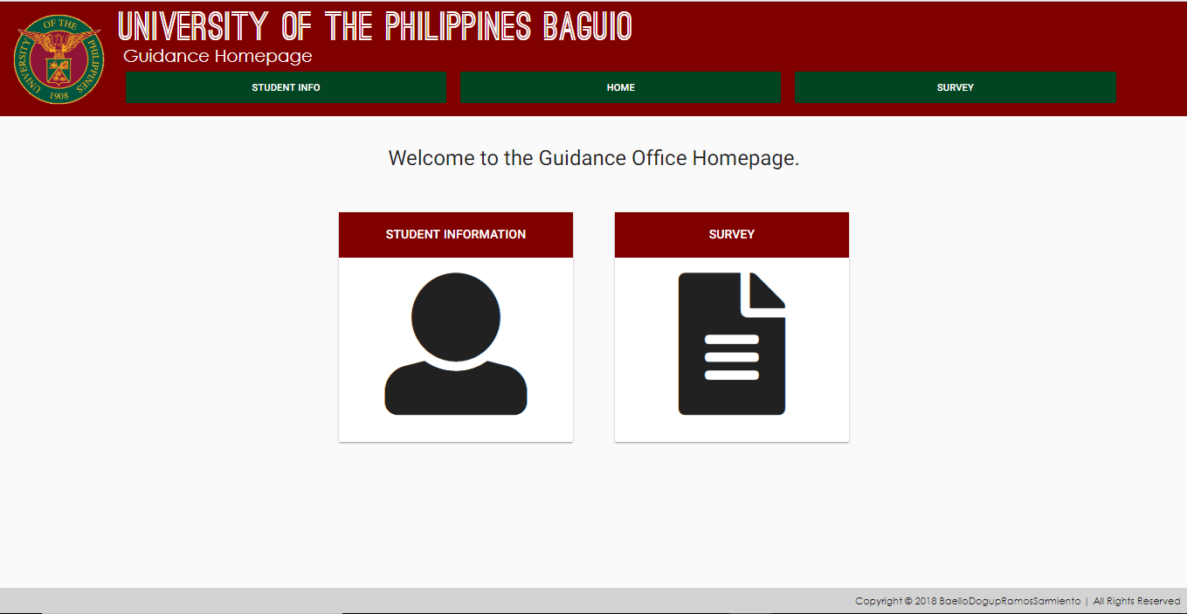

The Homepage

**1.0 GENERAL INFORMATION**

This section explains the system and the purpose for which it is intended.

* 1. **System Overview**

The Guidance DB is a web application which allows the user to input and edit Student Information into its own database, using an admin-configurable student form. It can also take surveys from students and give passwords to students (by batch) to grant them access to those surveys.

* 1. **Organization of the Manual**

The User Manual is divided into four sections: General Information, System Summary, Getting Started, and Using the System’s Functions.

* The General Information section explains in general terms the system and the purpose for which it is intended.
* System Summary section provides a general overview of the system. The summary outlines the uses of the system’s software requirements, system’s configuration, user access levels and system’s behavior in case of any contingencies.
* The Getting Started section explains how to get Guidance DB and presents the system’s menu & usage.
* Using The System’s Functions section provides a detailed description of the system functions.

**2.0 SYSTEM SUMMARY**

This section provides a general overview of the system. The summary outlines the uses of the system’s software requirements, system’s configuration, user access levels and system’s behavior in case of any contingencies.

**2.1 System Configuration**

The Guidance DB can operate on any mobile/PC device with any operating system that has a browser. The application does not require a connection to the internet but requires a connection to the server (UP Server at the time of the manual’s production) in order to save data onto the database. Data saved can be seen on the server’s database and some data can be seen on the site given the right privileges. After accessing the website’s URL, the Guidance DB can be used without any further configurations.

**2.2 User Access Levels**

Everyone connected to the serve can view and access the application, but not everyone can use the website’s main functions. Only the administrator can use & access the Student Information Menu while the Survey Menu can be accessed by both the administrator and any “appointed” students.

**2.3 Contingencies**

In case of an active(in-use) device’s disconnection, data are not saved in the internal memory of the device, and users cannot submit the data into the database unless connected again.

**3.0 GETTING STARTED**

This section explains how to get Guidance DB and presents the system’s menus briefly.

**3.1 Installation and Logging In**

The website can be accessed via a specific URL in any browser on your device (w/ an OS). It can also be saved as an HTML file which opens the URL immediately on-click. User ID and Password are given to the administrators so they can enter these every time they are prompted.

**3.2 System Menu**

The Guidance DB operates as a tabbed application, which consists of three tabs.



**3.2.1 Student Info Tab-** the first tab is the Student Info tab that contains 3 sub-selections which are all only accessible by the administrator. The user will automatically be prompted to login when this tab is selected.

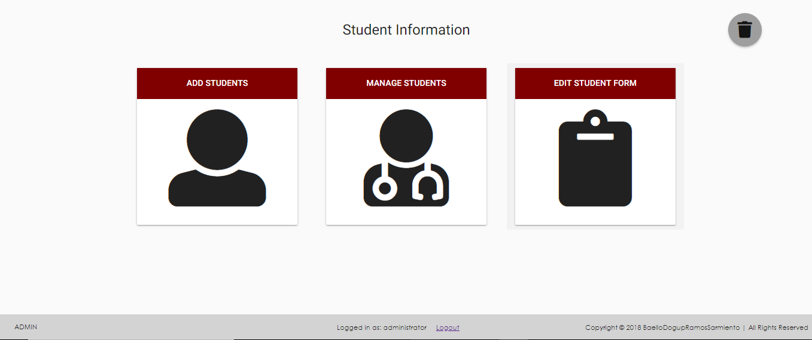

[Student Info Tab]- Add Students

This tab contains three selections: “Add Students”, “Manage Students” and “Edit Student Form”, from left to right respectively.

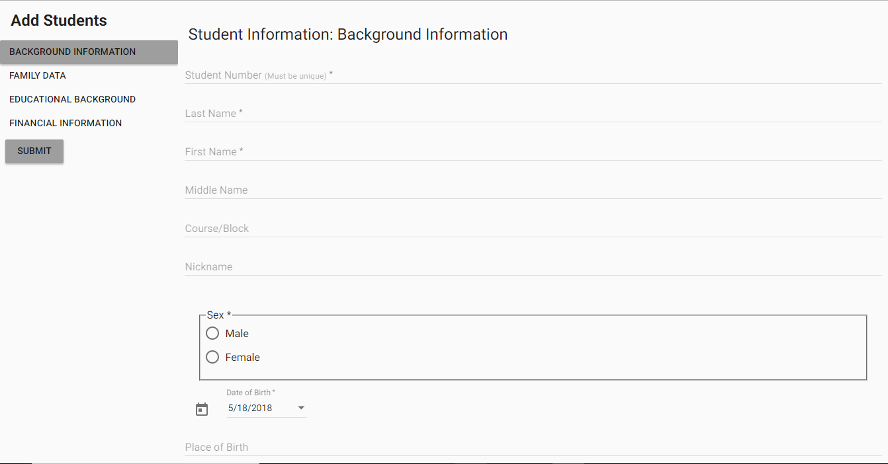

Fig 1.0 - Add Students

As seen in Fig 1.0, this is what the “Add Students” selection would look like when clicked. In *default*, there are four tabs on the left and one submit button. These tabs contains all sorts of input fields (text field, radio fields or true or false field, checklists, etc.) with some fields that are required and therefore they must be filled up before they can click the Submit button and register the student into the server’s database.



[Student Info Tab]- Manage Students

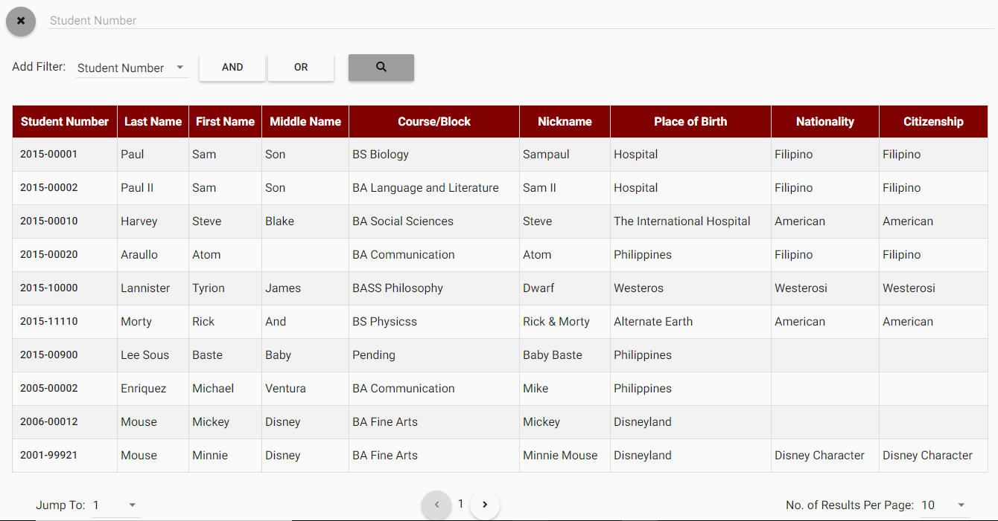

Fig 2.0 - Manage Students

In Figure 2.0, we can see the “Manage Students” selection, which is for viewing & editing current students who are registered in the database. In this example, the database is already filled with some sample students, and the “Add Filter” (boxed area on fig 2.0) configuration is already set as the Student Number.

Now, there is a lot to consider in this selection so we will first explain the “Add Filter” configuration. At the start, it would look like this:

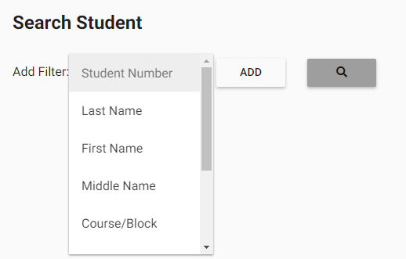

To configure it, you must first select which detail of the student you are looking for, would you like to narrow down. For example, if we select the “Last Name” from the drop-down menu, and we select Add, it would look like this:

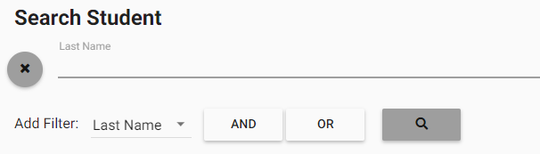

This means that if we write a Last Name we want, for example, Dela Cruz, then click the magnifying glass icon, all students with that last name would appear. Additionally, we can click “AND” or “OR” so that we can narrow down our search into students with the Last Name: Dela Cruz AND a student number of 2015, or students which either has a Last Name of Dela Cruz OR a student number of 2015.

Now, for the Edit Student tab, we can click the one of the student’s student number (circled in Figure 2.0), and we can see that student’s student information.

For example:

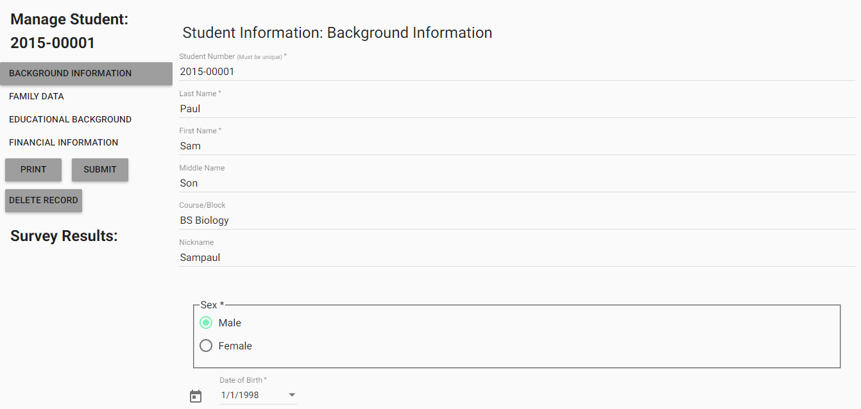

In the Edit Student tab, we can change information about the student, print the student’ info, or delete the student’s whole records.



[Student Info Tab]- Edit Student Form

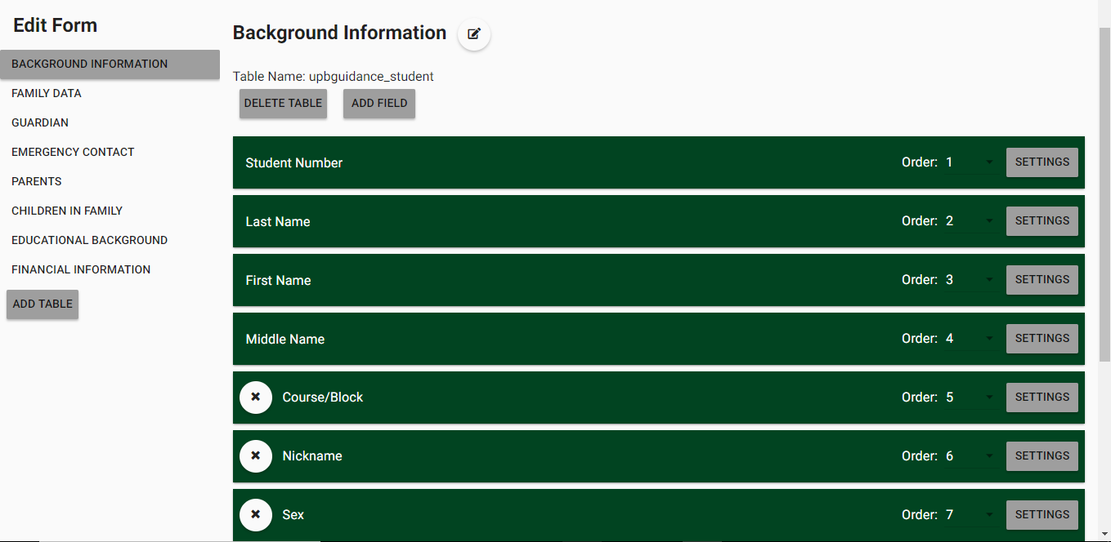

Fig 3.0 - Edit Student Form

Figure 3.0 is how the Edit Student Form tab would look like, in default. There are a lot of buttons in this tab, so buttons would just be highlighted in different colors one by one.

Red Box-Select Table Button- clicking one of these buttons would let you edit fields in that specific table.

Light Blue Box-Add Table Button- this button allows the user to create another table in the student information form.

Light- Green Box-Edit Table Title- this button allows the user to change the table name.

Brown Box-Delete Table- allows the user to delete an existing button in the student info form.

Violet Box-Add Field- adds a field into the current selected table.

Navy Blue Box-Order Menu- shows a drop-down box which you can select from to arrange a field’s order.

Black Box- Remove Field- clicking this “x-like” button would delete the field It is in line with.

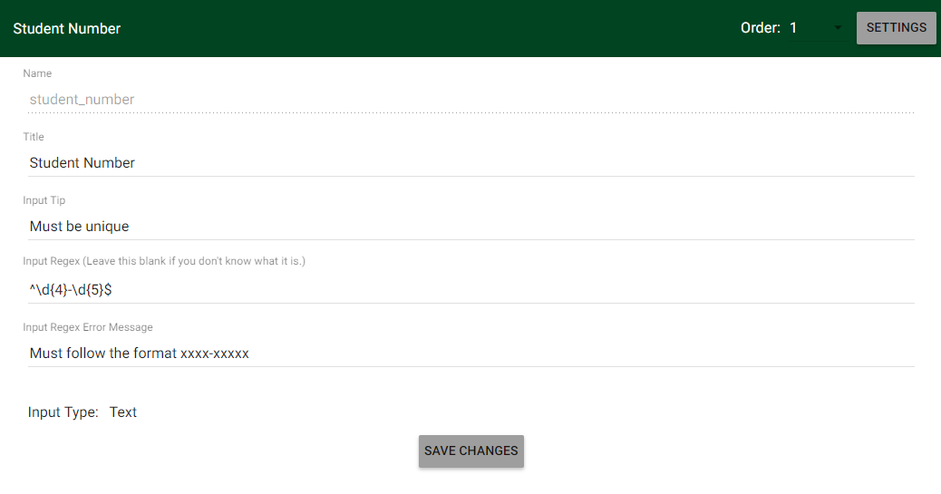Green Box- Field settings- clicking this would expand one field so you can set it up, and it looks like this:

Clicking the “Add Field” which is mentioned a while ago would also look a bit like this. We can see here that we can edit the field’s name, Title, insert a tip, input an inputregex, error m essage and input type.

**3.2.2 Home Tab-** the second/middle tab would transfer you to the Guidance DB’s Homepage.



**3.2.2 Survey Tab-** the third tab is the Survey Tab and it contains 2 sub-selections one accessible by Students and one only accessible by administrators. The user will automatically be prompted to login when this tab is selected.

When you click this tab, it would look like this:

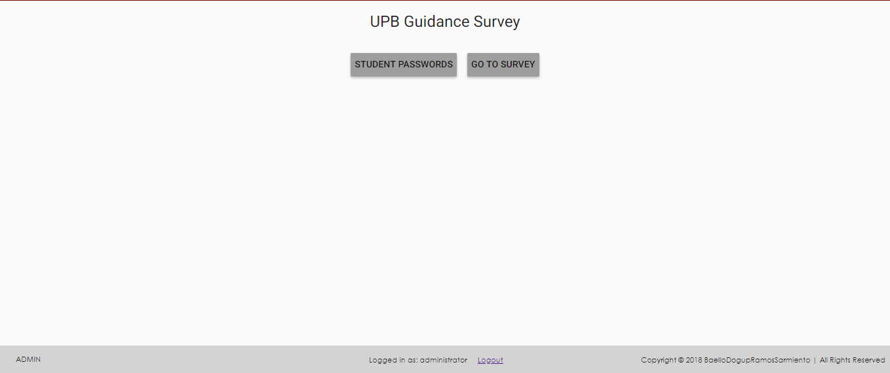

[Survey Tab]- Student Passwords

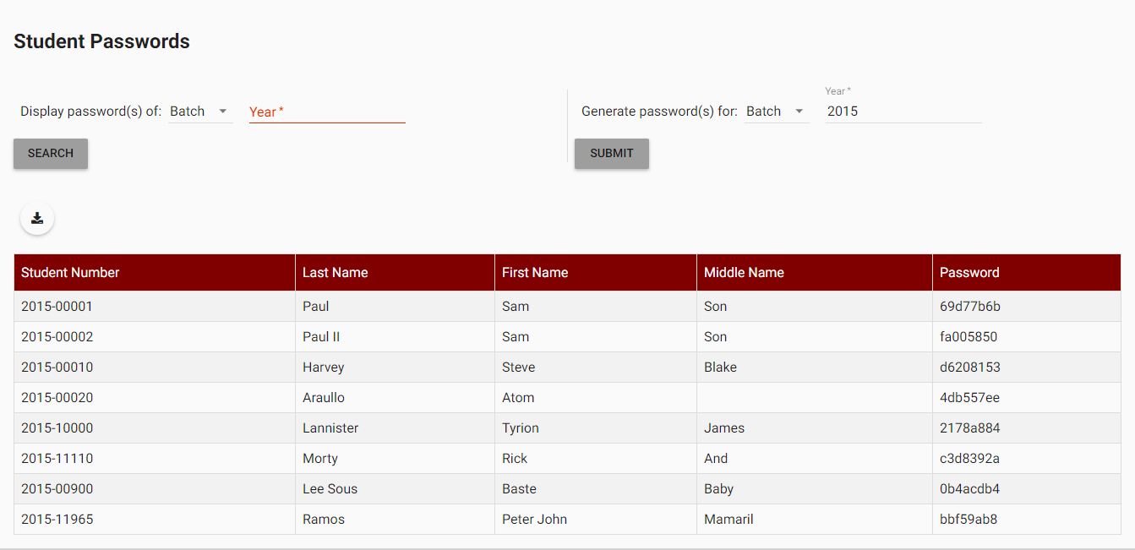

Figure 4.0- Student Passwords

Figure 4.0 represents the “Student Passwords” selection, which has the purpose of generating and displaying passwords for any batch of students or any individual student. In this example, we already have a database of sample students and we have already given them a password by typing our desired batch and then clicking submit. After generating a password, they would automatically displayed in a table.

We can also export these passwords in case they are needed to be distributed to the students using the download button, which is encircled in Figure 4.0.



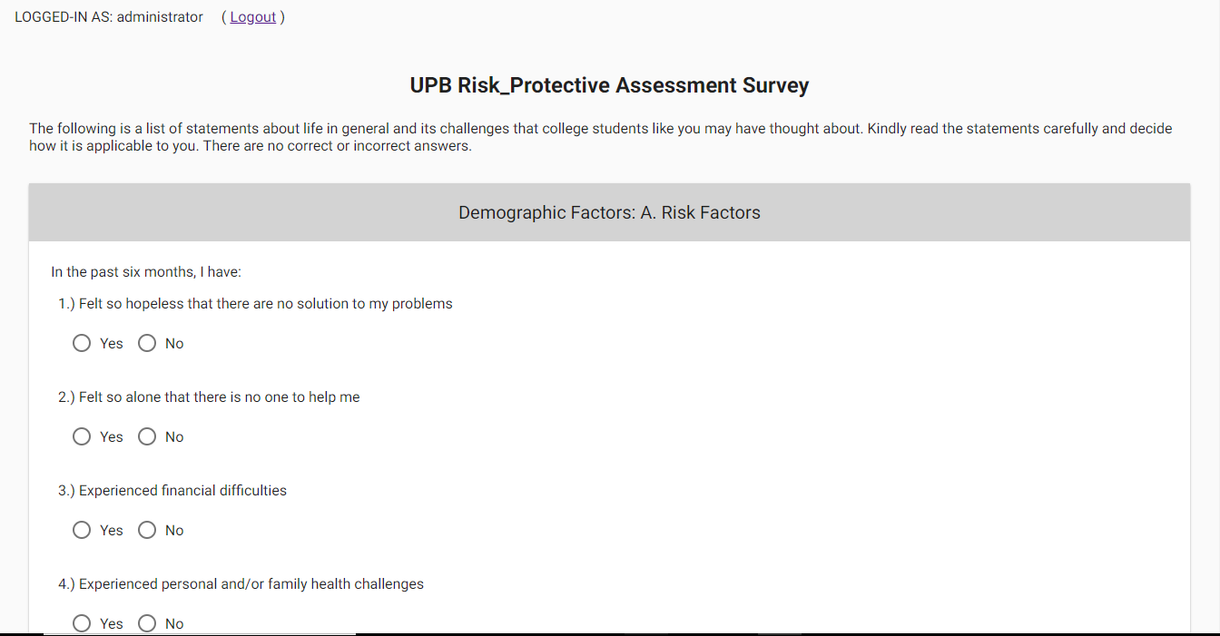[Survey Button]- Go to Survey

Figure 5.0 - Go To Survey

In figure 5.0, we can see the “Go To Survey” selection, or simply the Survey tab, which contains the Survey questionnaire that is answerable by the current logged in user. The user must simply answer all questions presented and click the submit button in the lowermost portion of the questionnaire.

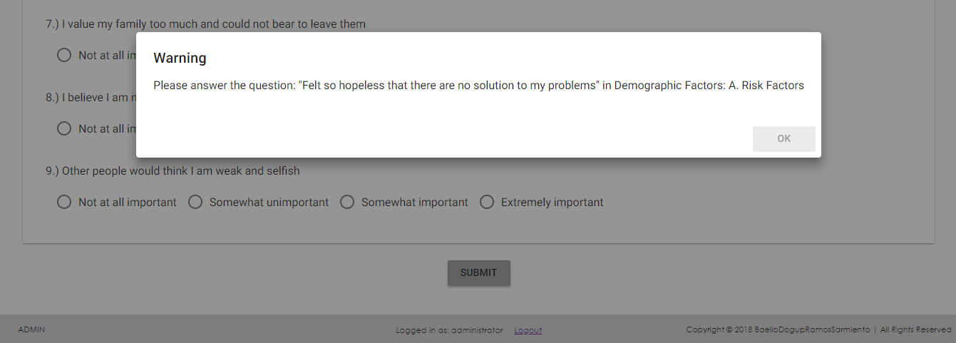

Figure 6.0 - Survey Submit Button

We can see an example of a warning/error message in Figure 6.0 that is produced when submitting an incomplete survey, indicating which question isn’t answered yet.

**3.3 Changing User ID and Password**

Changing user ID and Password can only be done by the administrator in the “Admin” Page, which is located in the bottom-left corner of the page.

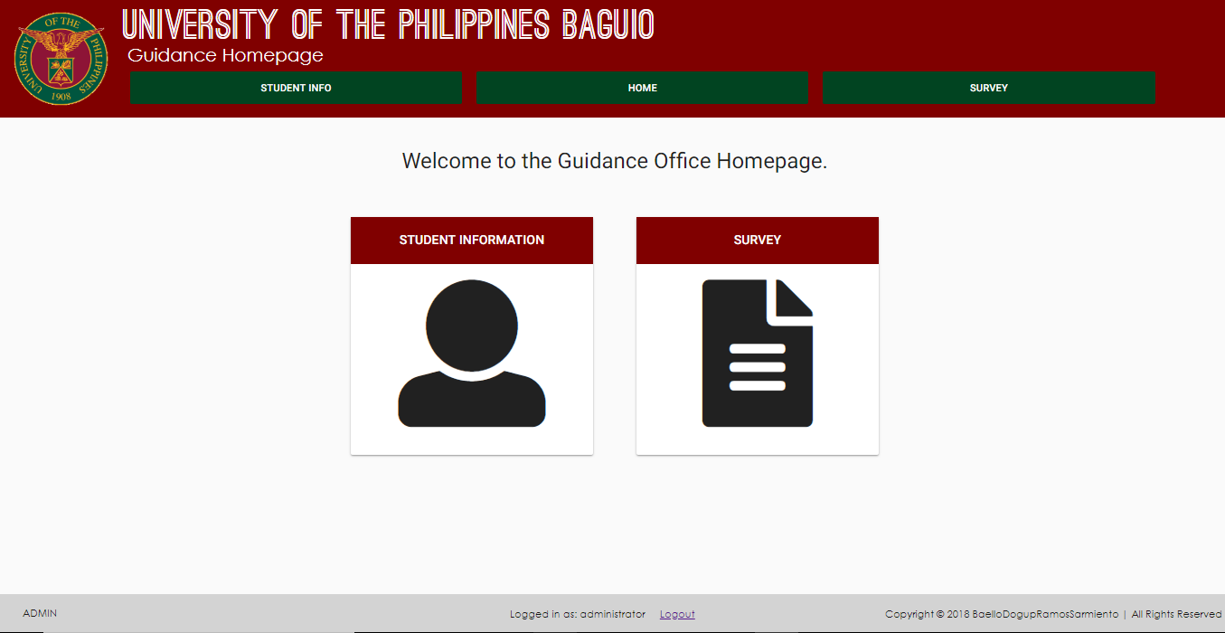

If you click that, the “Admin Page” would appear, which would look like this:

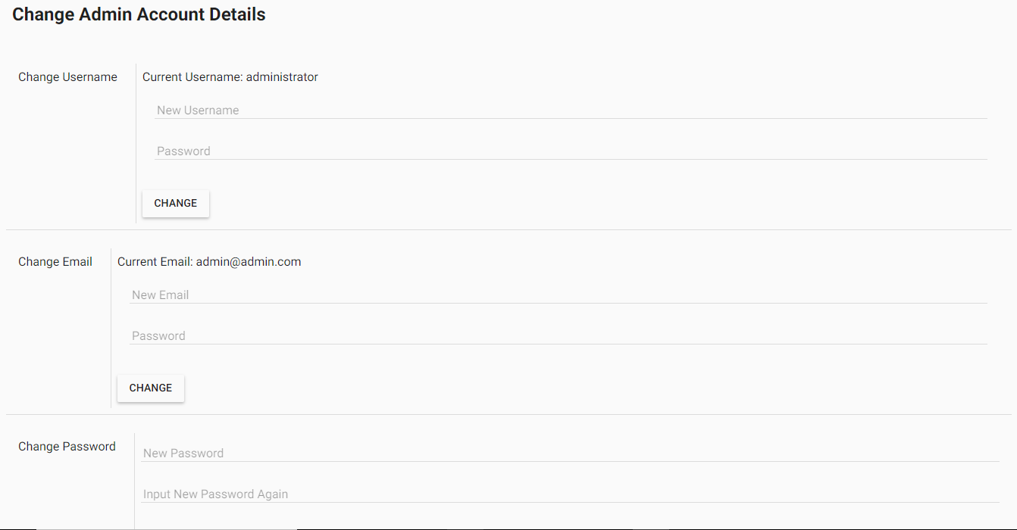Figure 7.0 - Admin Page

In this page, you can “Change your username”, “Change your Email”, or “Change your Password”, which means exactly that. You can change the administrator’s username, email and password, but you can only change the student’s student number and password, using the Student Information tab and using the Student Passwords tab, respectively.

**3.4 Exiting the System**

The Guidance DB application can be closed simply by clicking the “X” button on the top-right corner of your browser, any any other ways that would close your browser.

**4.0 Using the System’s Functions**

Since we’ve already discussed how to use the system in the previous sections, in this section, it will be discussed how they are all interlinked and some special instructions in case of error.

**4.1 Using the System**

1. ) When using the system for the first time, it is recommended to add some students first in the Add Students section of the Student Info tab, as most of the application’s functions would be useless if there are no students in the database.
2. ) When you’re filling-up the Student Information form and you are not satisfied with the questions/fields, you can always change that in the Edit Student Form section.
3. ) After registering some students in the database, you can always view them in case you want to check if there’s any error and also print them when needed. These can be done in the Manage Students section, by simply searching for the student/s and clicking their student number. There, you can see his/her information and there’s a print button when you need to export their information.
4. ) In case you want the currently registered students to answer some survey for you, you should go into the Students Passwords section of the Survey Tab first, and generate a password for a student, or a whole batch of students if needed (e.g. batch 2015). Once the password has been generated, you can print the passwords and give it out to the students one by one or you can simply tell them their passwords when they ask them.
5. ) If the students already has their passwords, they can be instructed to login to the site and go to the Survey tab and click the Go To Survey section. There, you can immediately see the questionnaire which is already ready to be answered.

**4.2 Special Instructions for Error Correction**

In case the user was disconnected, it is recommended that they reconnect to the server or go to the server’s range (in case it’s out of reach) to avoid an unnecessary loss of data.